For this analysis we have taken “politics” as a topic in Twitter. The application analyzed the tweet text and sent the sentiment of the tweet from: very positive, positive, neutral, negative, very negative, to the Kafka producer. We then created a visualization to analyze what is the main sentiment in the tweets over a period of about 6 hours. We created a graph of the Sentiment and its respective count over the duration of the application run time which was 6 hours and we got the following results. 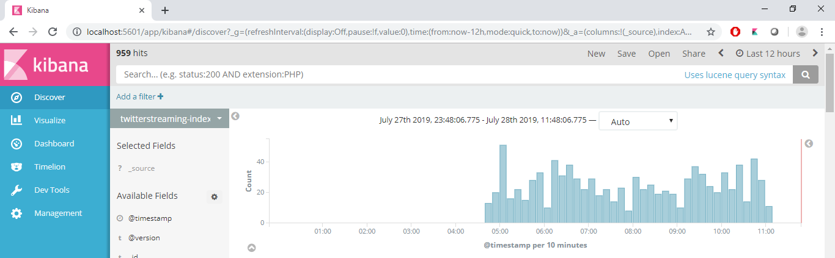

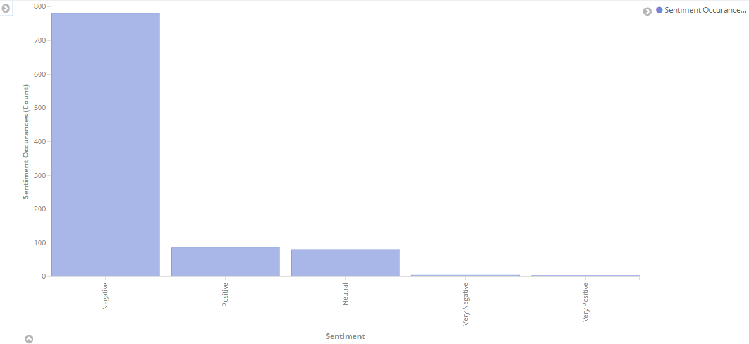

Over the time in which the application was running negative tweets were more dominating than the other for topic: politics.